Prof. V. B. Shah Institute of Management,

R. V. Patel College of Commerce (ENG. MED.),

V. L. Shah College of Commerce (GUJ. MED.) &

**Sutex Bank College of Computer Application & Science**

(Accredited ‘B’ (CGPA 2.55) by NAAC Dec.-2009)

Veer Narmad South Gujarat University, Surat



Bachelor of Computer Application

(5th Semester) Year 2025-26

**AIRSTRO**

**Guided By:**

Asst. Prof. Twinkle S. Panchal

**Submitted By:**

647 - Nishil Chavda

658 - Deep Sorathiya

678 - Rahul Gadhiya

**INDEX**

|  |  |  |
| --- | --- | --- |
| **NO** | **CONTENT** | **PAGE NO** |
| 1 | Introduction | 2 |
| 2 | Objectives | 6 |
| 3 | System Flow Diagram | 7 |
| 4 | DFD/UML Diagram | 9 |
| 5 | ER Diagram | 12 |
| 6 | Database Design | 13 |
| 7 | System Design | 15 |
| 8 | References | 22 |

**1. Introduction**

* 1. **Project Description**

The **Airstro – A Next-Generation Flight Booking & Travel Experience Platform**. Airstro is designed to streamline the experience of flight search, booking, and travel management for both users and administrators by providing an easy-to-use and visually appealing platform.

The system is fully responsive, mobile-friendly, and features a modern professional UI for improved usability.

The **Airstro** consists of two major panels:

* **Admin Panel**
* **User Panel**

**Admin Panel**

* Login is required using admin email and password.
* Admin can add new flights, update flight details, or delete flights.
* Admin can view all flights available in the system.
* Admin can view all user bookings along with passenger details.
* Admin can update booking status or delete bookings if necessary.
* Admin dashboard provides a centralized flight & booking management interface.

**User Panel**

* Users can Register/Login using email and password for authentication.
* Main navigation includes: Home, Deals & Offers, My Trips, About Us, Login, Signup
* Home Page displays Hero section, booking widget, offers, and recommended destinations.
* About Page describes Airstro’s mission and international network along with loyalty benefits.
* Flight Search Page allows users to search for flights based on:
  + From / To
  + One-Way / Round-Trip
  + Travel Date(s)
  + Number of Passengers
  + Class Type (Economy / Business)
* Flight Results Page shows available flights with:
  + Filters (airlines, stops, time slots)
  + Sorting (price, duration, time)
  + Expandable details & price comparison
* Users can select a flight and complete the booking instantly.
* My Trips Page displays:
  + All booked flights
  + Total fare
  + Booking status
  + Users can cancel flights anytime
* Users cannot book or manage flights without logging in.
  1. **Project Profile**

|  |  |
| --- | --- |
| **Project** **Title** | **Airstro** |
| **Frontend** | **HTML, CSS** |
| **Backend** | **PHP** |
| **Database** | **MySQL** |
| **Browser** | **Chrome, FIREFOX, SAFARI** |
| **Platform** | **VS Code, Xampp** |
| **Internal Guide** | **Prof. Twinkle S. Panchal** |
| **Submitted To** | **Prof. Twinkle S. Panchal** |

**2. Objectives**

**Start to End Process:**

1. **Collecting Information for the System**

(Requirement Gathering and Analysis).

1. **Designing the System**

(Preparing the design based on gathered information).

1. **Creating Database Structure**

(Defining and implementing table structures).

1. **Front-end and Back-end Integration**

(Connecting user,admin interface with the backend functionalities).

1. **Custom Functions & Validations**

(Implementing system-specific functions and data validations).

1. **Making the Design Responsive**

(Ensuring mobile-friendly, responsive design).

1. **Testing**

(Verifying functionality, usability, and performance).

**3. System Flow Diagram (SFD)**

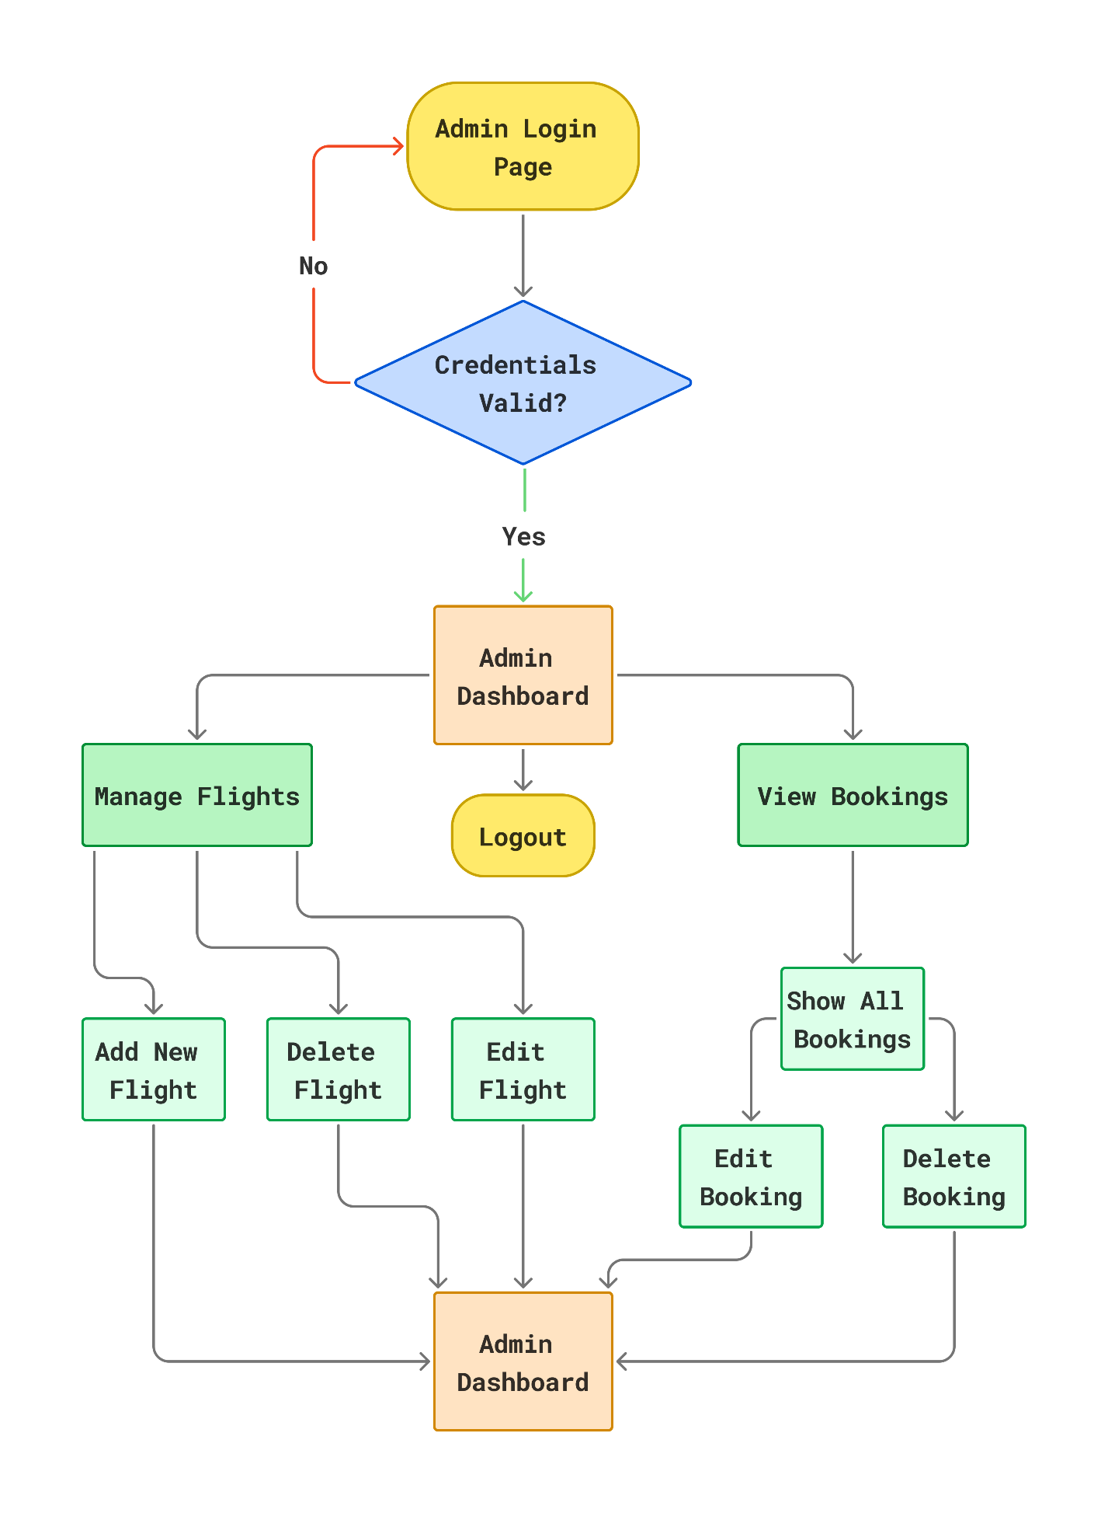**Admin Process Flow Diagram**

**User Process Flow Diagram**

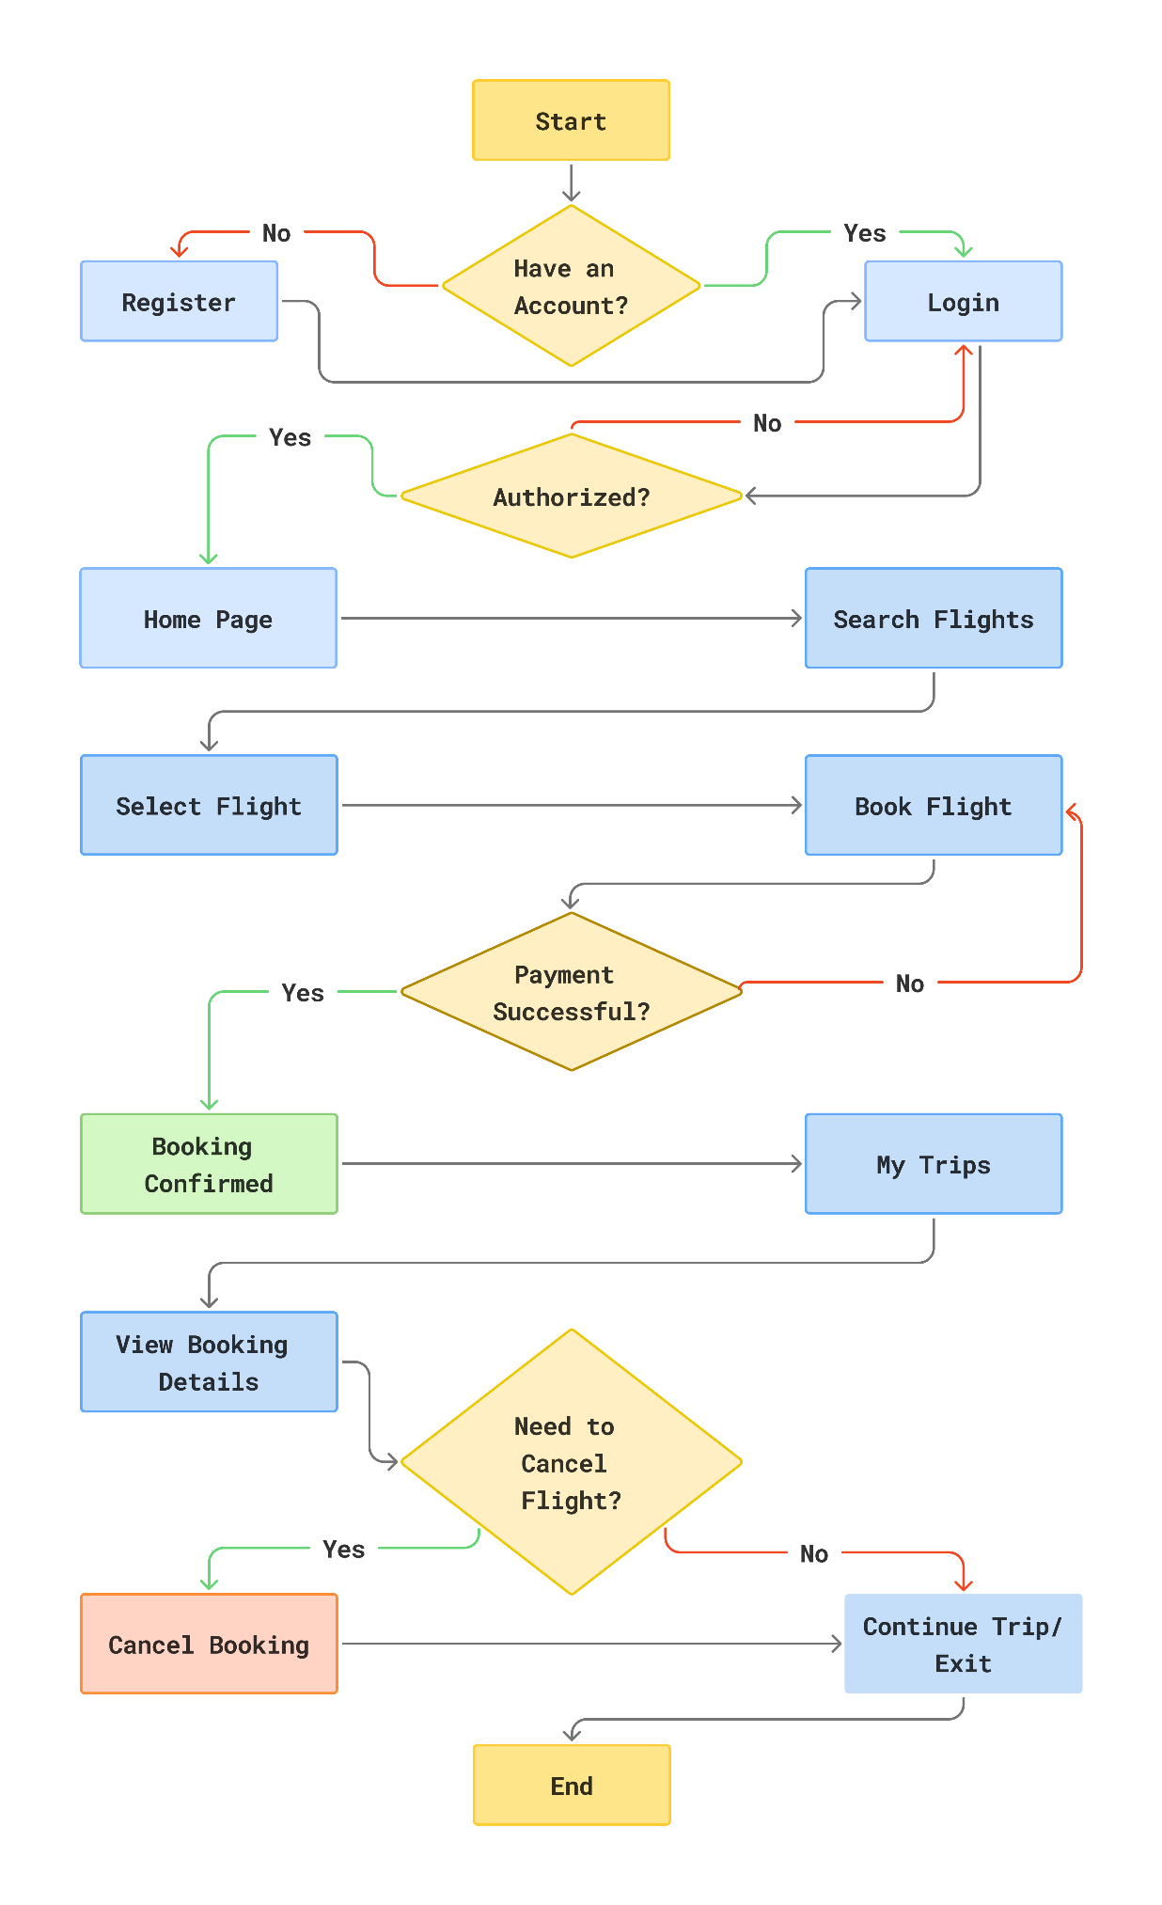

**4. DFD and UML Diagram**

**0 Level Diagram (Context Diagram)**

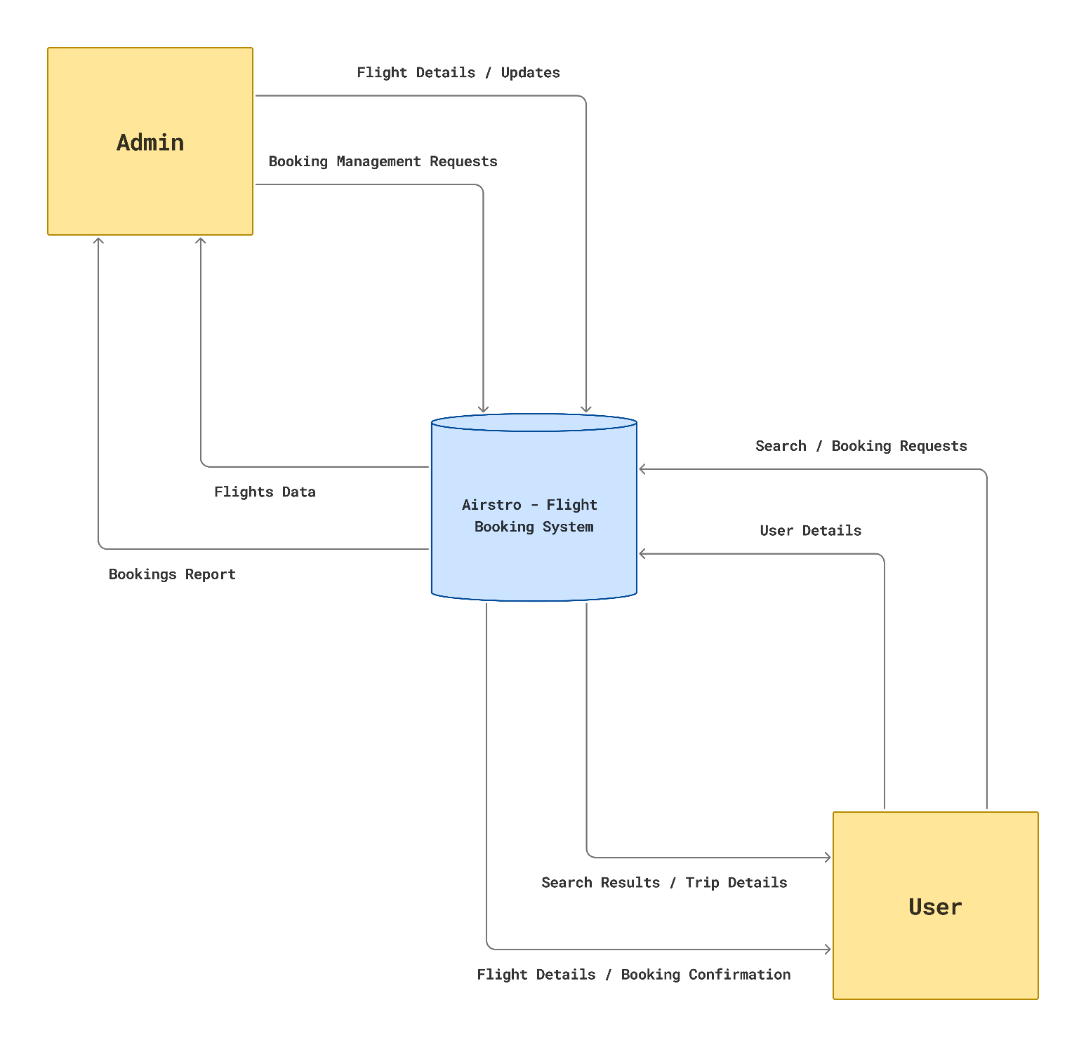

**1 Level Admin Diagram**

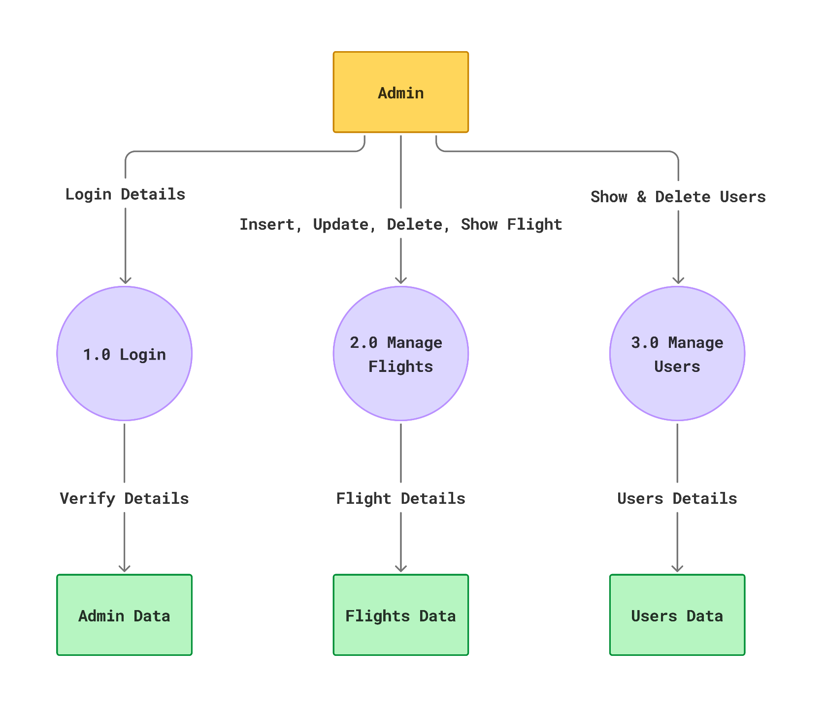

**1 Level User Diagram**

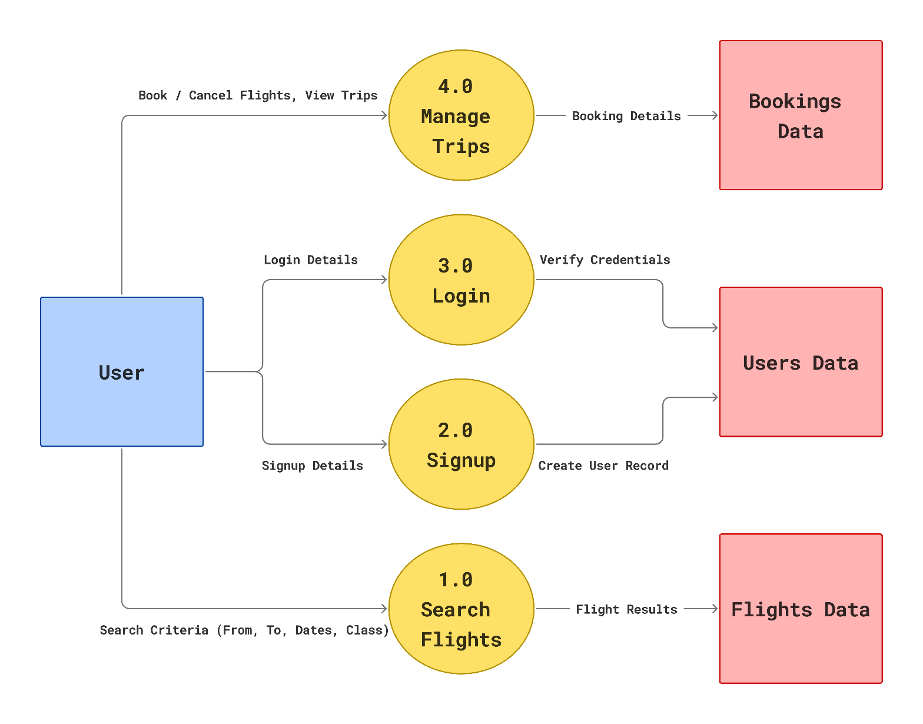

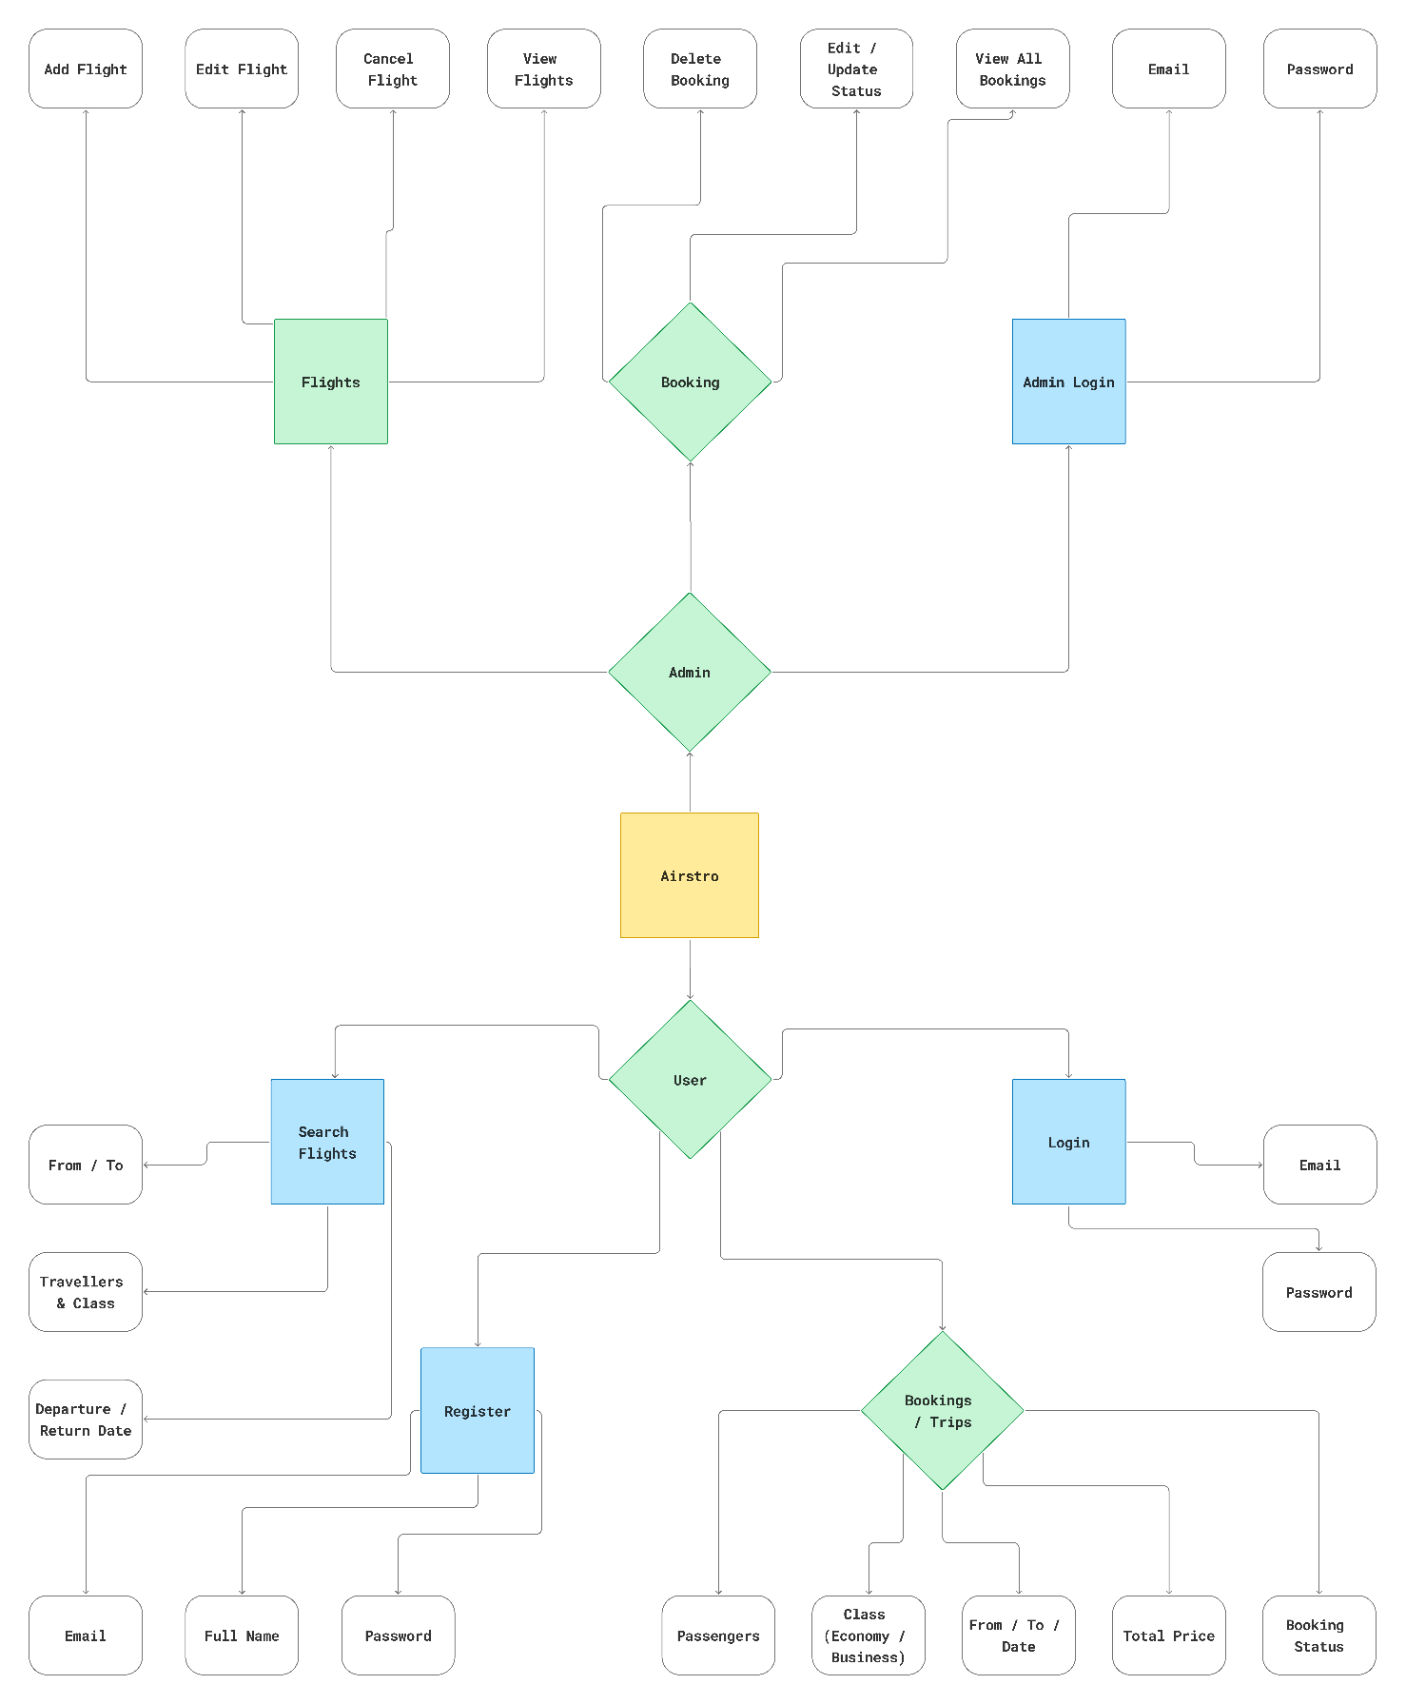**5. ER Diagram**

**6. Database Design**

**Admin Table**



**User Table**

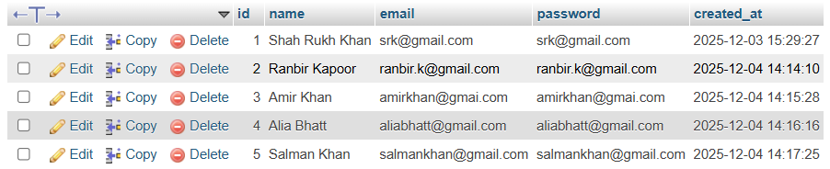

**Flight Table**

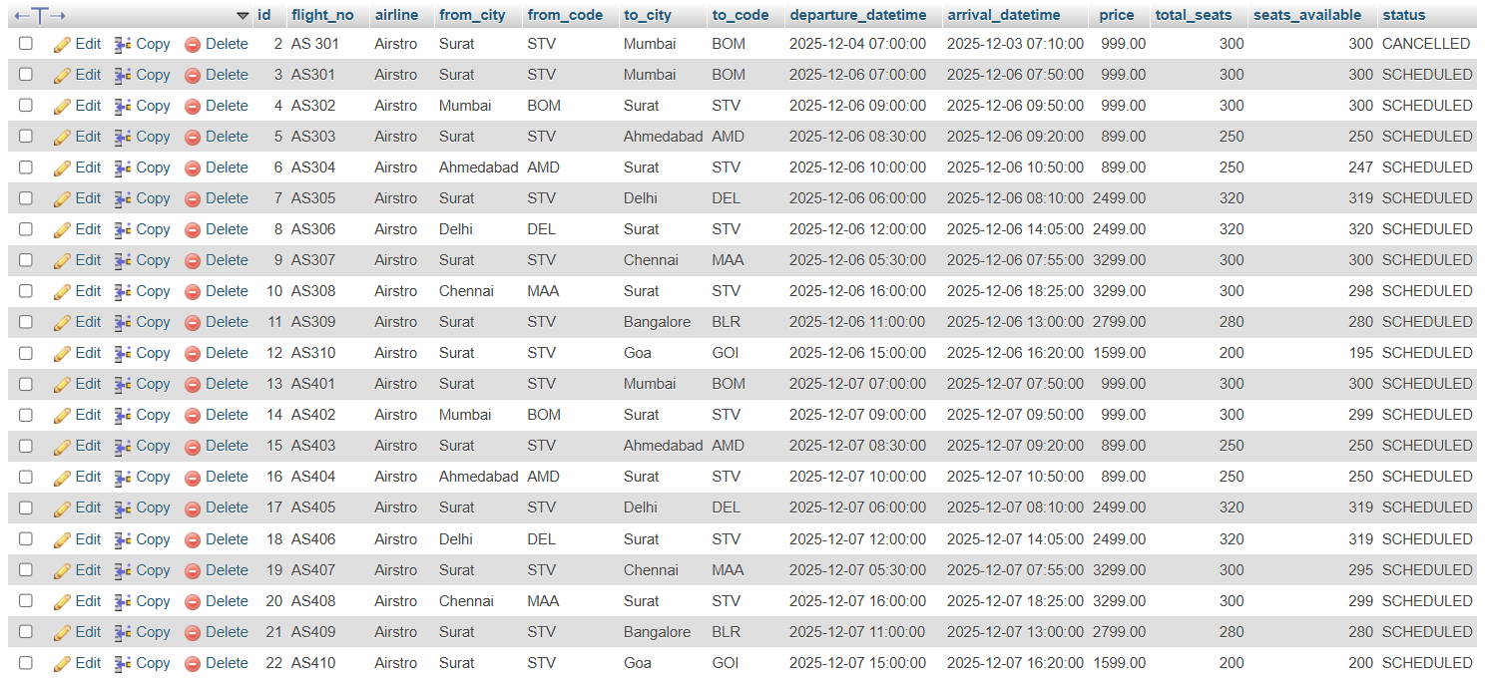

**Bookings Table**

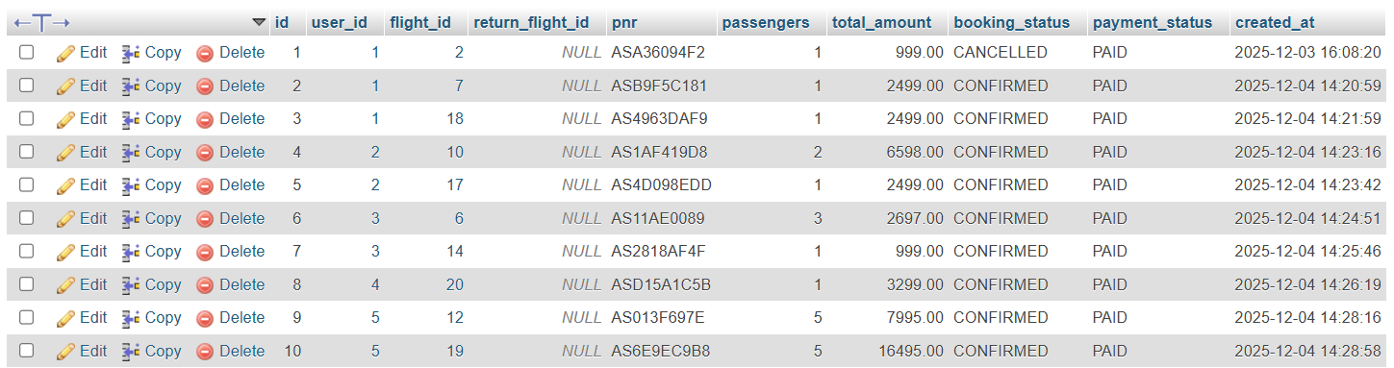

**Payment Table**

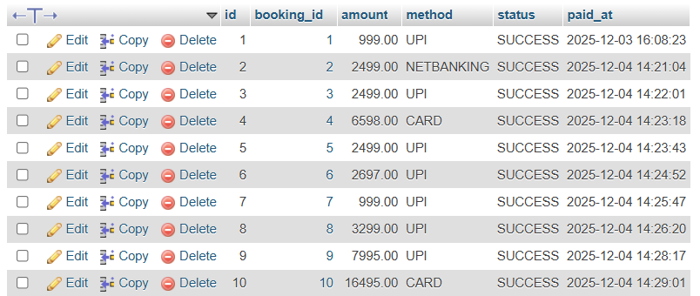

**7. System Design**

**Admin Login**

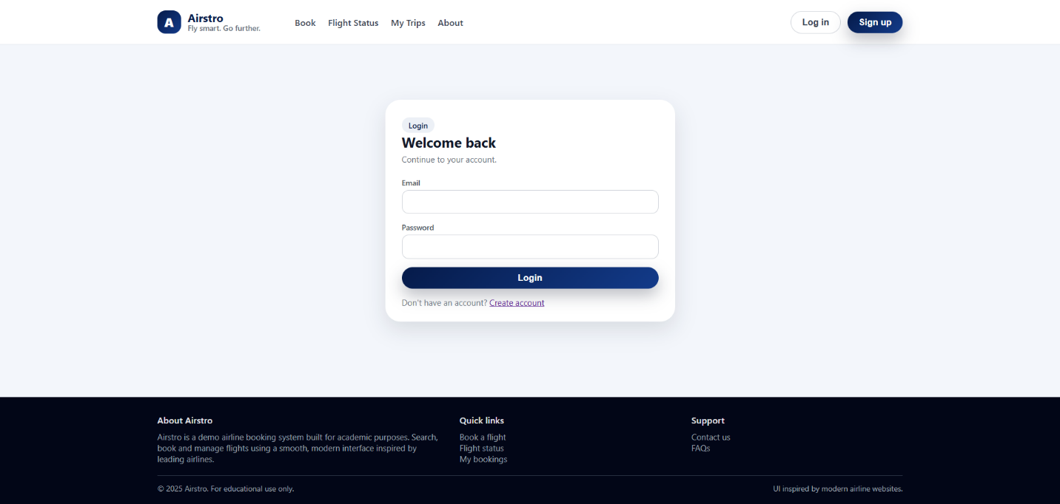

**Admin Add Flights**

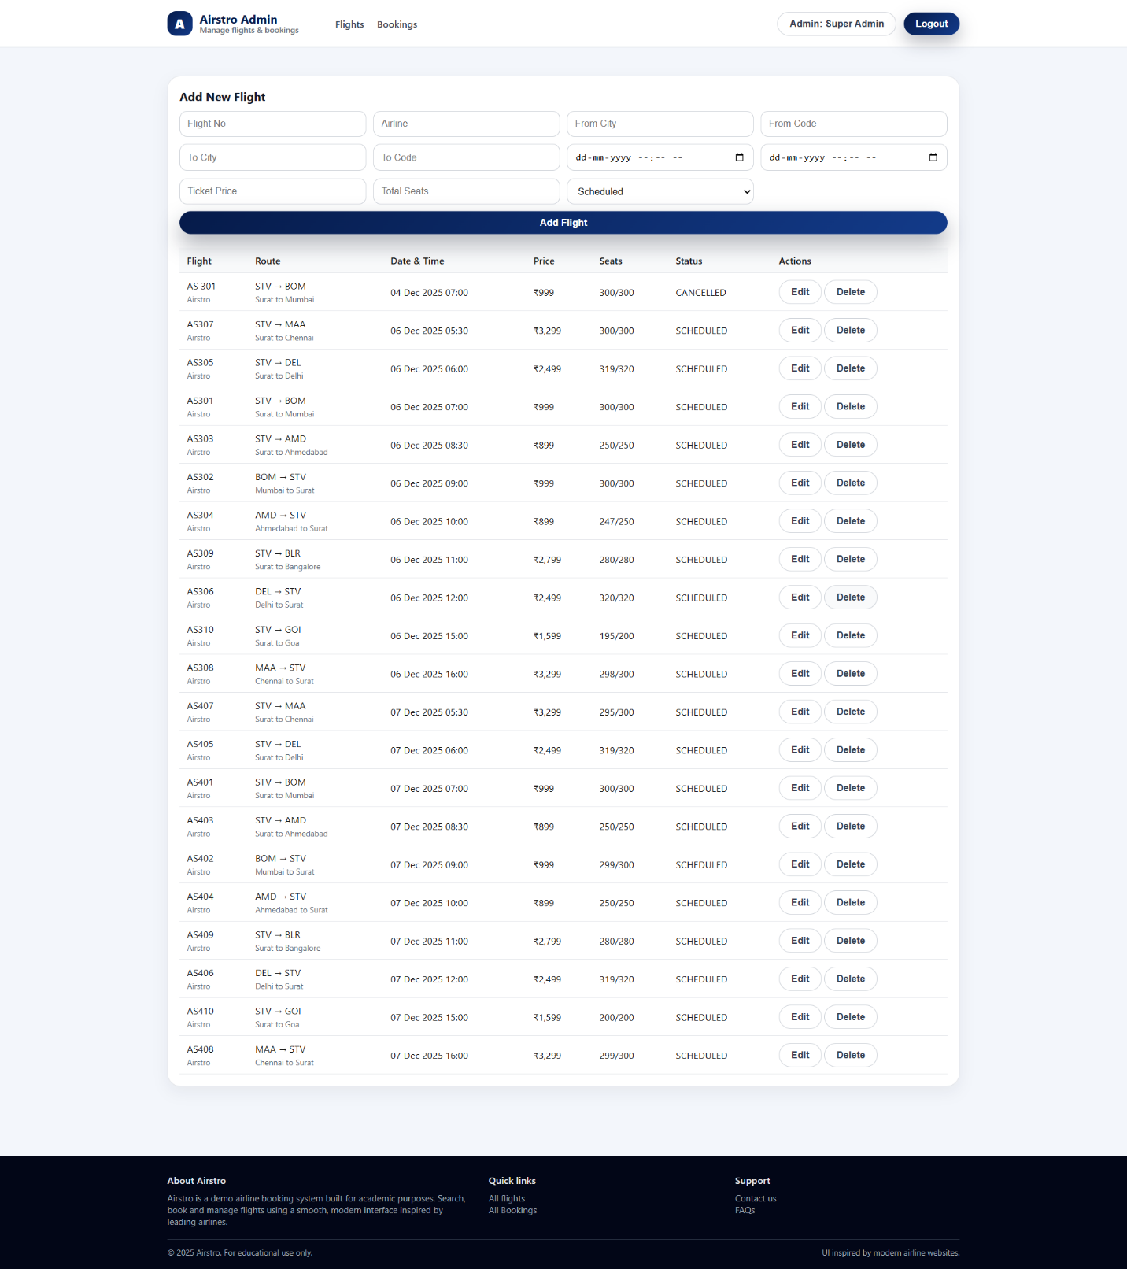

**Admin All Bookings**

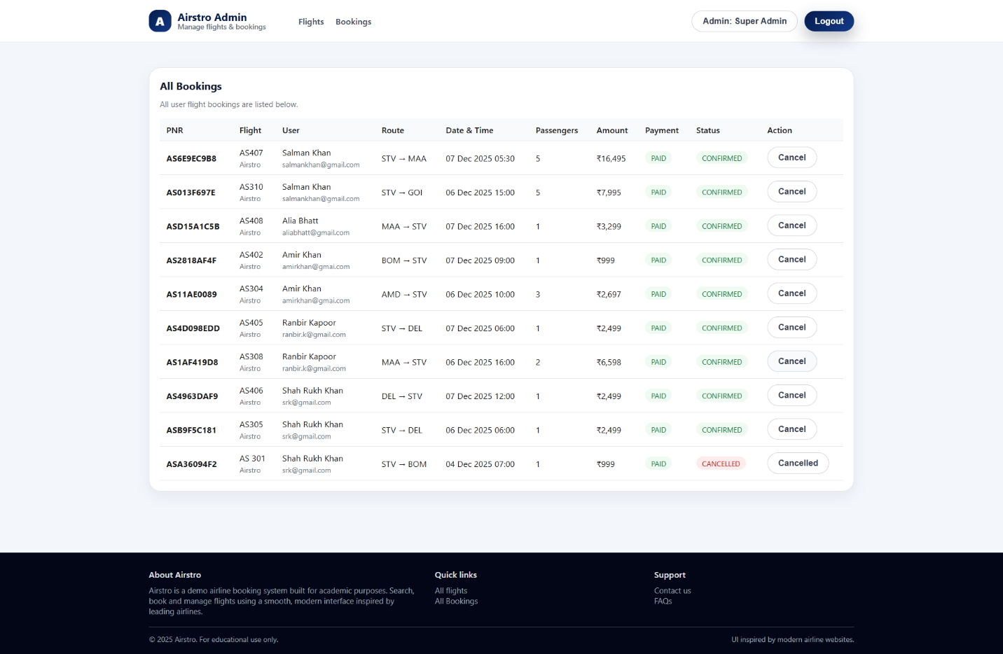

**User Login**



**User Signup**

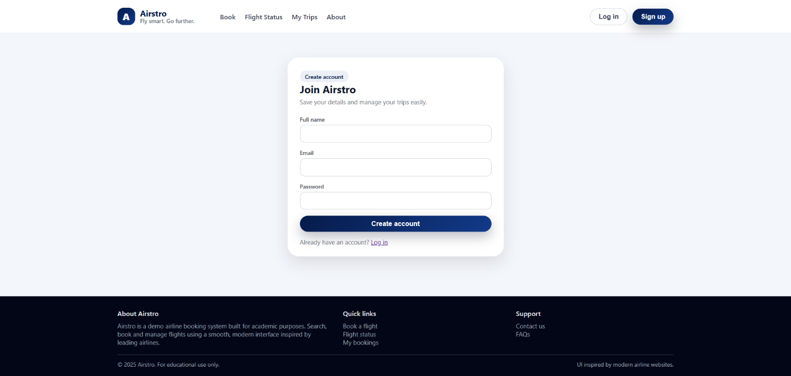

**User Home Page**

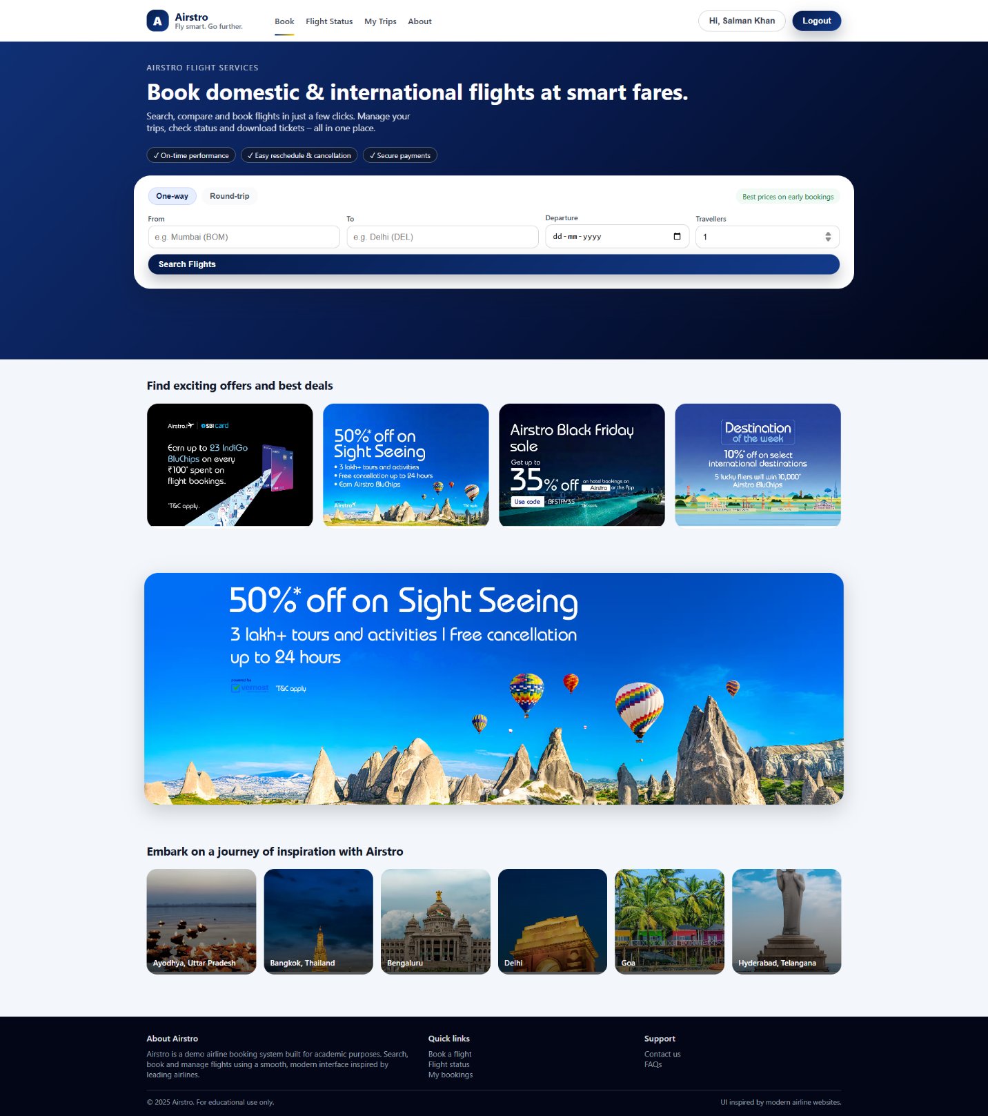

**User Flight Status**

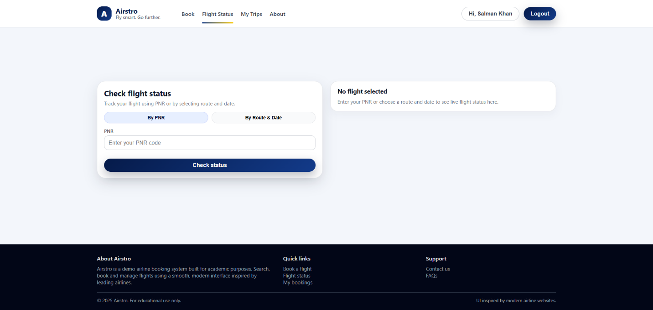

**User My Trips**

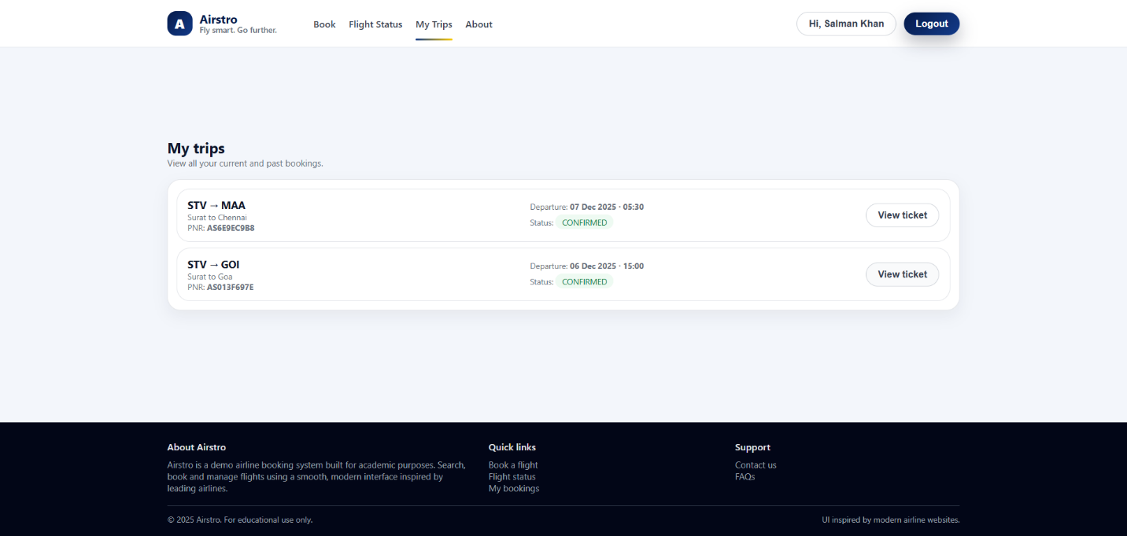

**About Us Page**

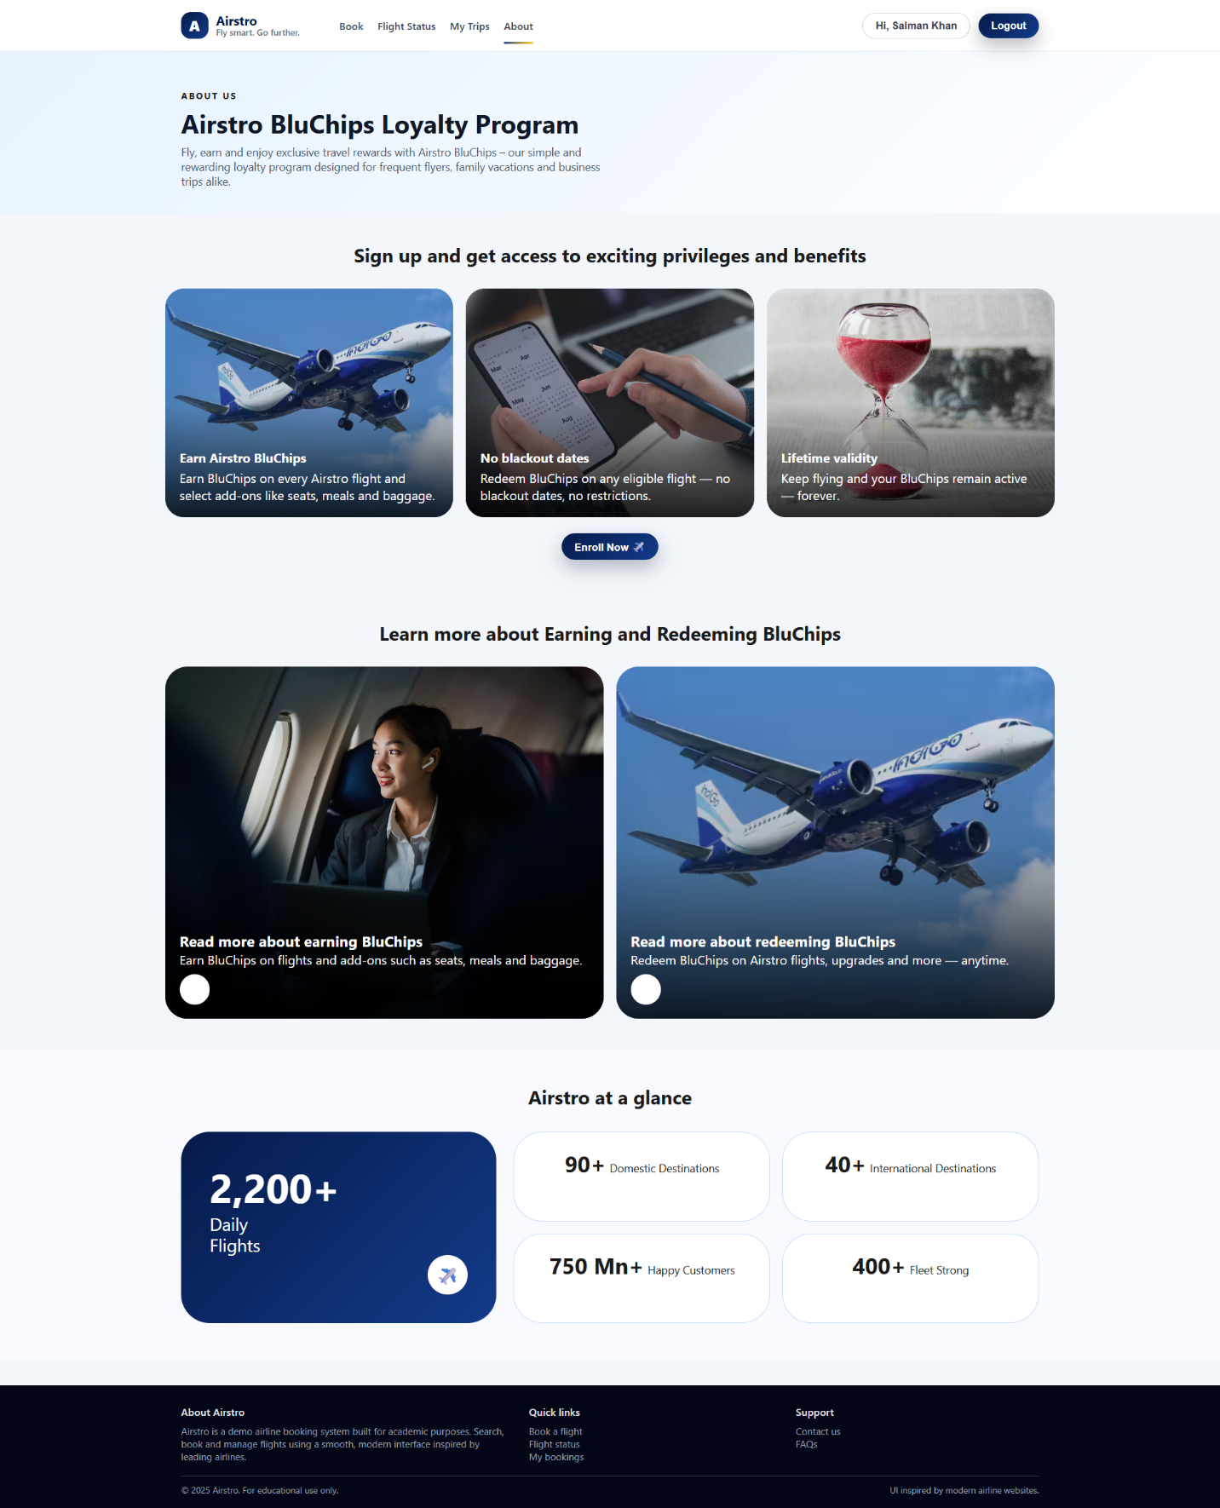

**8. PROJECT SUMMARY/REFERENCES**

**Summary**

* + The PHP Web Application is a role-based system built with PHP and MySQL, featuring separate modules for Admin and Client.
  + Users can register, log in, and manage their profiles, while Admins can monitor users, control content, and manage system operations.
  + The application uses a config module for database connectivity, a database folder for schema/data, and assets (CSS, JS, images) for UI design.
  + It demonstrates CRUD operations, session management, and secure role-based access.
  + This project showcases how PHP can be used to build dynamic, secure, and user-friendly web applications.

**🔗 References**

* **PHP Official Documentation -** [**https://www.php.net/docs.php**](https://www.php.net/docs.php)
* **MySQL Documentation -** [**https://dev.mysql.com/doc/**](https://dev.mysql.com/doc/)
* **W3Schools PHP Tutorial -** [**https://www.w3schools.com/php/**](https://www.w3schools.com/php/)
* **GeeksforGeeks PHP Tutorial -** [**https://www.geeksforgeeks.org/php-tutorials/**](https://www.geeksforgeeks.org/php-tutorials/)
* **PHP CRUD Operations (GeeksforGeeks) -** [**https://www.geeksforgeeks.org/php-crud-create-read-update-and-delete/**](https://www.geeksforgeeks.org/php-crud-create-read-update-and-delete/)
* **PHP Session Management (Tutorialspoint) -** [**https://www.tutorialspoint.com/php/php_sessions.html**](https://www.tutorialspoint.com/php/php_sessions.html)